## Test Data:

Link: <https://roomy-fire-houseboat.glitch.me/>

# TTT-1 (bug): Input field cuts off description text

**Steps to Reproduce:**

1. View the input field.

**Expected:**

* String is short enough to fit in the field or the field is large enough to fit the entire string.

**Actual:**

Text is cut off and indiscernible.



# TTT-2 (bug): Field input allows values less than 3

**Steps to Reproduce:**

1. Enter value as anything less than 3 (0 and negative integers are currently allowed but render nothing)
2. Click ‘Play’

**Expected:**

* Form validation is triggered.
* Informative message displayed to the user stating that boards cannot be less than 3x3.

**Actual:**

Boards are rendered which have no competitive value:

* Entering 1 renders a 1x1 where player 1 always wins.
* Entering 2 renders a 2x2 where player 1 always wins.

# TTT-3 (bug): Field input allows values greater than 20

While rendering a 500x500 grid is neat, it isn’t practical. **The browser starts crashing around 1000.**

**Steps to Reproduce:**

1. Enter values greater than 20.
2. Click ‘Play’

**Expected:**

* Form validation is triggered.
* Informative message displayed to the user stating that boards cannot be greater than 20x20.

**Actual:**

* Any number is allowed. Multiple rulesets I find reference 20x20 as the max (competitively or otherwise).

# TTT-4 (bug): ‘Congratulations’ message displays incorrect player

**Steps to Reproduce:**

1. Generate a board of 3 or more.
2. Complete a game while playing both sides.

**Expected:**

The correct winner is displayed in the ‘Congratulations’ message.

**Actual:**

O won here but X is displayed.

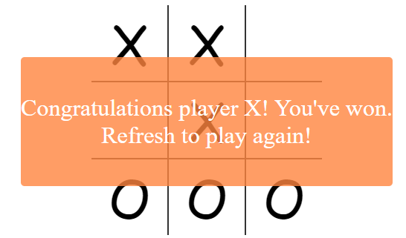

And here X won but O is displayed.

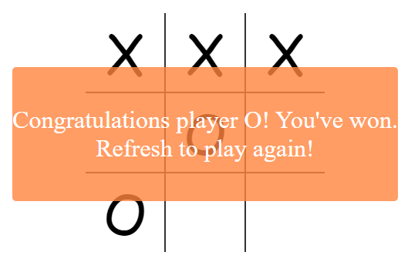

# TTT-5 (bug): Multiple boards are not separated in an understandable way

### **QA Note:** I am unsure if multiple boards being allowed is intended or a bug. For purposes of the assignment I will assume multiple boards are allowed.

**Steps to Reproduce:**

1. Enter a value of 3 or more.
2. Select ‘Play’ 2 or more times.

**Expected:**

More of a defining line between boards or an actual separation.

**Actual:**

Boards are stacked touching each other with no discernable line.

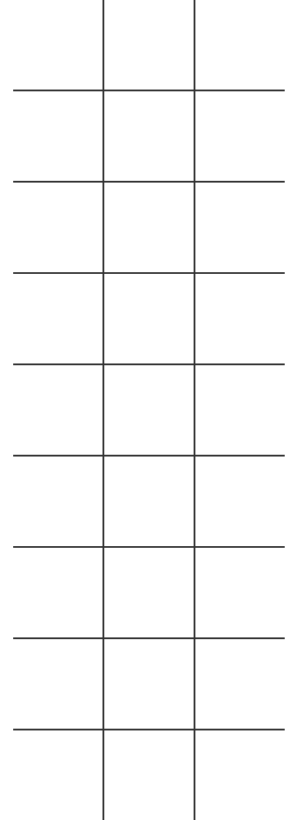

# 

# 

# 

# TTT-6 (bug): Actions on multiple boards are not isolated to the selected board

**Steps to Reproduce:**

1. Enter a value of 3 or more.
2. Select ‘Play’ 2 or more times.
3. Begin playing on any board but the first.

**Expected:**

Actions are rendered on the selected board.

**Actual:**

If all boards have the same amount of cells then all actions are rendered on the first board. Seems due to the 1:1 mapping of the same amount of cells. The game below was played entirely on the second board, but it rendered on the first. **This happens regardless of board count.**

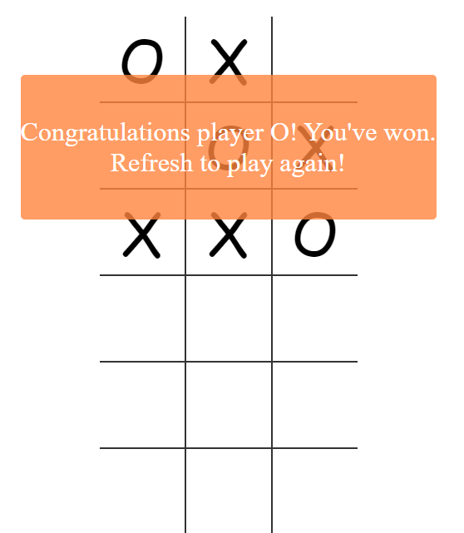

If the first board has Y amount of cells, and the rest all have Z, then things are a little different.

Below is a screenshot of 3 boards. The first is 3x3, and the last two are 4x4. Colored circles indicate which click matches which rendered action.

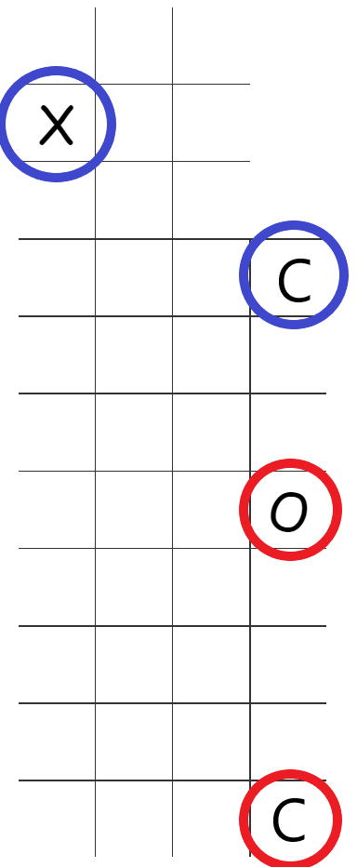

If the boards have varying cell-sums (ex: a 3x3, then a 4x4, then another 3x3) then things get really weird and it would take at least another page to type up the behaviors. I will move past this one for the sake of the assignment.

Basically all actions are mapped to the first board, unless the selected board has more cells than the first, in which case the actions render on the board above.

* The only exception is boards with a greater number of cells than those above them. If you select a cell in a board with a cell-sum greater than any one board above, then the action has nowhere to go and renders on itself. In some cases it doesn’t render at all (like with the varying cell-sum boards)
* If the corresponding cell has already been rendered in then nothing happens.

# TTT-7 (bug): Nothing happens on stalemate

**Steps to Reproduce:**

1. Create a 3x3 board
2. Play against yourself to achieve stalemate

**Expected:**

* Message is displayed much like the ‘Congratulations’ message but instead it reads:
  + “Stalemate! Refresh to play again!”

**Actual:**

* Nothing happens

# TTT-8 (bug): 404 on GET /client.js

**Steps to Reproduce:**

Navigate to the home TTT page and watch the browser console.

**Expected:**

No console errors.

**Actual:**

Error on GET /client.js 

# 

# 

# TTT-9 (bug): Cells can be selected and rendered after game is over

**Steps to Reproduce:**

1. Create a new game.
2. Play it to completion while leaving empty cells.

**Expected:**

The board should no longer be interactable.

**Actual:**

Players are able to continue selecting cells and have values rendered.

# 

# TTT-10 (task): Move the field description outside field and add details

The criteria message should be more robust, user friendly, and visible.

**A/C**

* Move the field description underneath the field and ‘Play’ button.
* Change description to read:
  + “Enter a number greater than 3 and less than 20 to generate a tic tac toe board”

# TTT-11 (task): Disable play button till valid entry is detected

The ‘Play’ button should be disabled until a value between 3 and 20 is entered.

This would prevent:

* Non-competitive games
* Site crashes

**A/C**

Make the ‘Play’ button clickable only if a value is entered in accordance with TTT-7.

# TTT-12 (task): Implement informative error handling on form validation

Users should always understand why they are not getting a result.

**A/C**

* Display an error message above the field in red if the entered value is not in accordance with TTT-7.
  + For values less than 3 display “Please enter a number between 3 and 20”
  + For values greater than 20 “Please enter a number between 3 and 20”
  + For non integer strings “Please enter a number between 3 and 20”

## 